ECE 684 – Natural Language Processing
Assignment 4 – Part-of-Speech Tagging
Nruta Choudhari

Comparing the model predictions with the truth from the Brown corpus:

Sentence 10150:
Those coming from other denominations will welcome the opportunity to be informed.

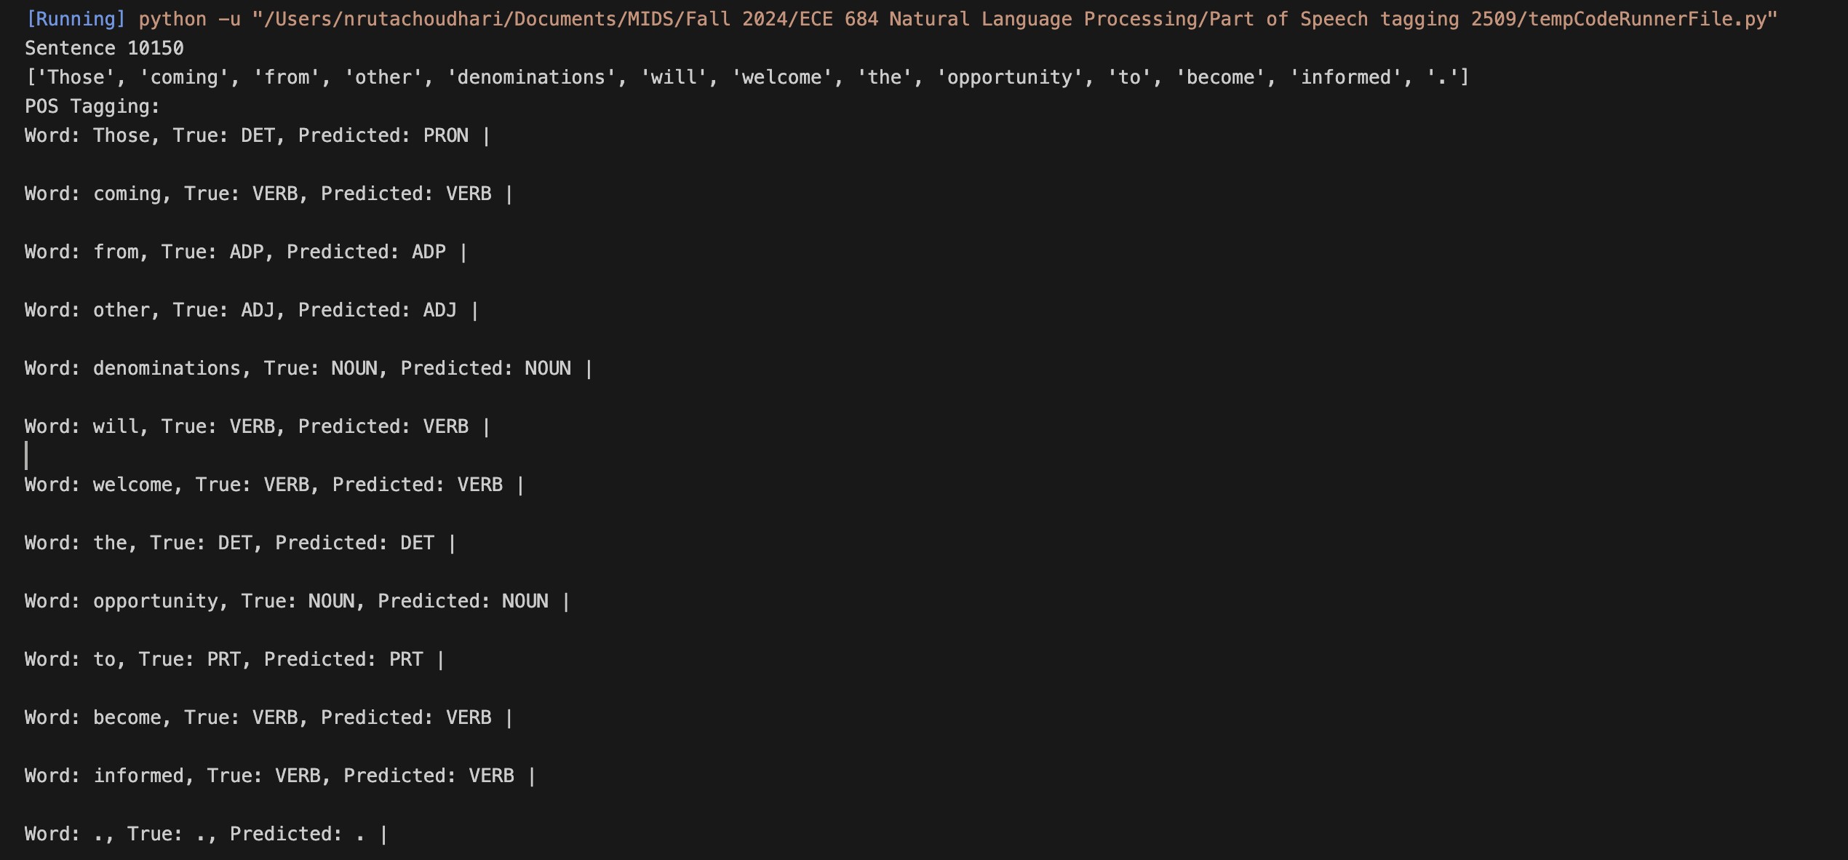

The model incorrectly predicts “Those” as a pronoun (PRON), while the Brown corpus tags it as a determiner (DET). I believe that the error is mostly due to how the word “Those” is represented in the training data. In most of the cases, it functions as a pronoun, and the model might have learned a more common pattern of tagging it as one.

Sentence 10151:
The preparatory class is an introductory face-to-face group in which new members become acquainted with one another.

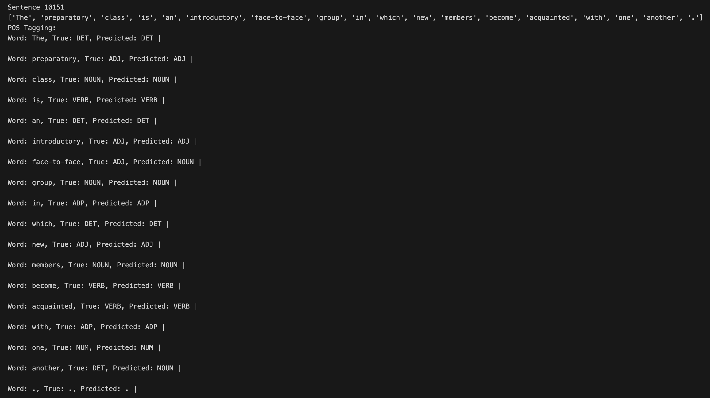

In this sentence, the model incorrectly predicts the tags for “face-to-face” and “another”, predicting both the words as nouns (NOUN) while the accurate taggings from the Brown Corpus are adjective (ADJ) and determiner (DET) respectively. This might happen because “face-to-face” can sometimes be used as a noun, confusing the model. The model could have misclassified the word “another” as it is often followed by a noun.

Sentence 10152:
It provides a natural transition into the life of the local church and its organizations.

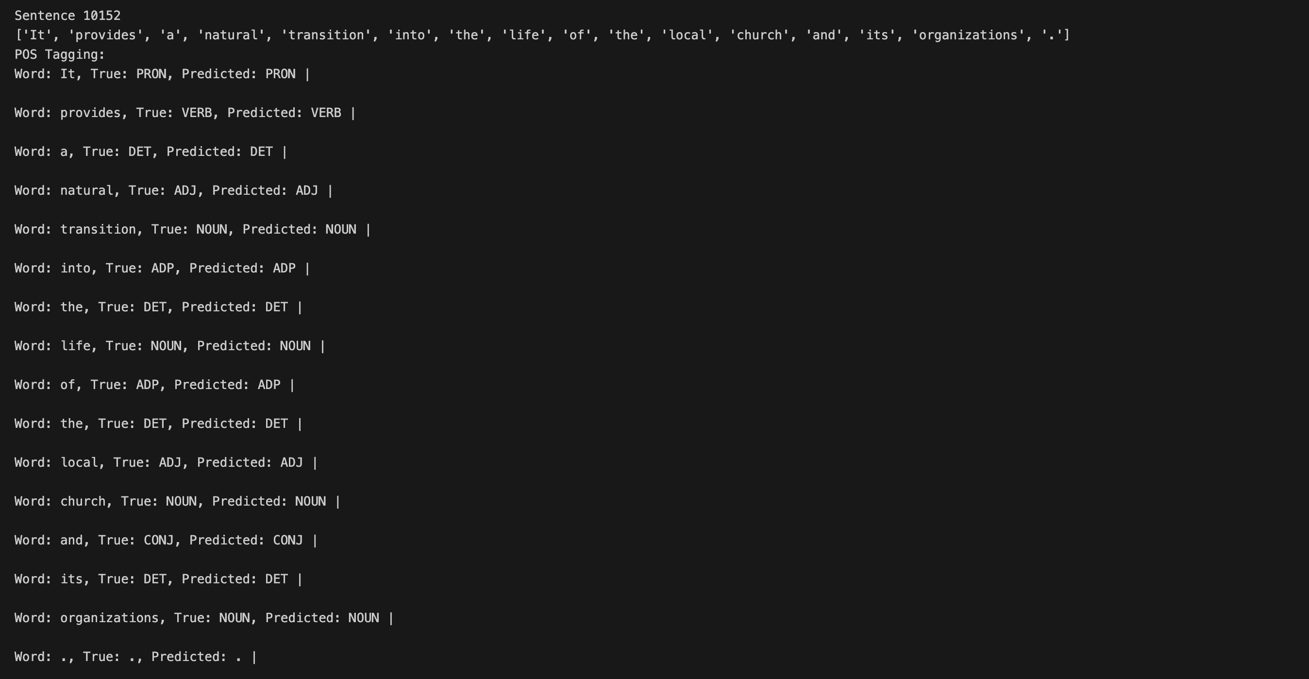

In this sentence, all model correctly predicts the tags for all the words. This might be because the sentence structure is similar to the patterns the model learned from the training data.

